**Cloning Repository**

I cloned and did my part to Krisha’s laptop since my personal laptop is barely functioning that’s why my only option for now is to borrow. Back to the agenda first I get the link of our group repository then copy paste the link by issuing git clone command to completely clone our group repository.

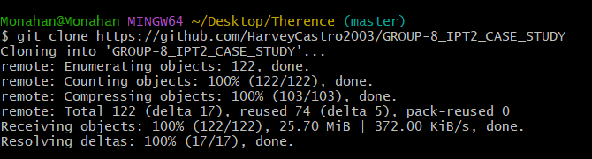

**Creating Branch, Adding, Committing and Pushing my HTML file with JavaScript**

Usually, I’ll always do is to first check what files are there by typing $ ls. Then, it moves into a folder called GROUP-8_IPT2_CASE_STUDY and check what's inside. Next, I go into the ALLFOLDER directory, then into SUBA_FILES, checking what files are in each place. With Git commands, you see what branches exist with $ git branch, I make a new one named Suba-Branch, and add tjportfolio.html to be ready for saving with $ git add. I commit my changes using the command $ git commit These records my modifications with a brief description. Then, I push my changes to the remote repository with $ git push -u origin, setting the upstream branch. Finally, to push changes to the specific branch I created, Suba-Branch, I use $ git push --set-upstream origin Suba-Branch.

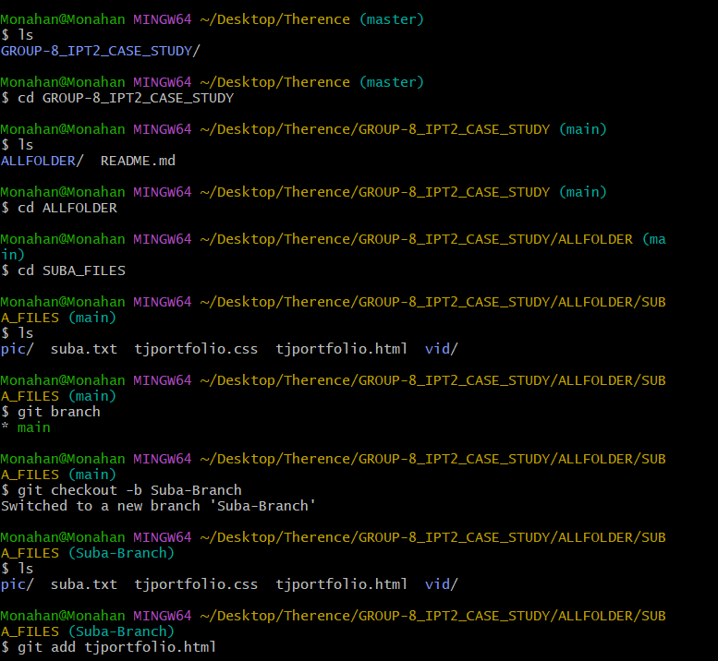

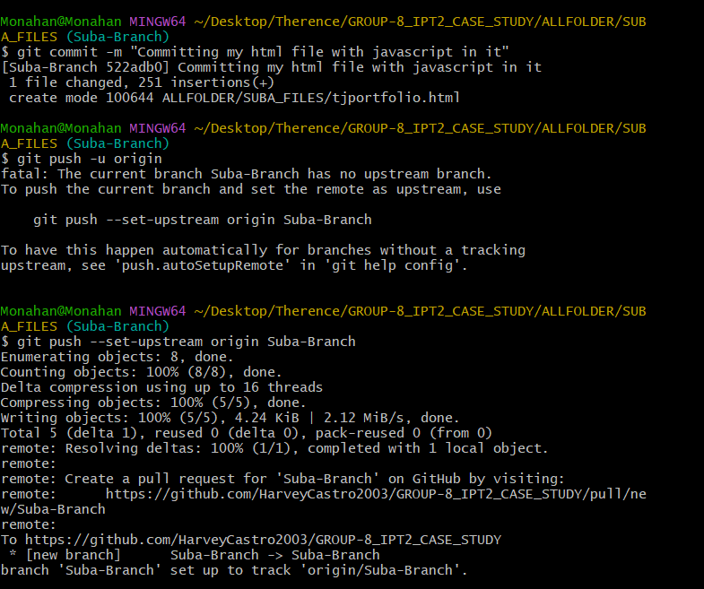

**Pull Request in GitHub**

I did Pull Request basically it is a method to propose changes to a repository so now my co-members can be reviewed of what are the changes.

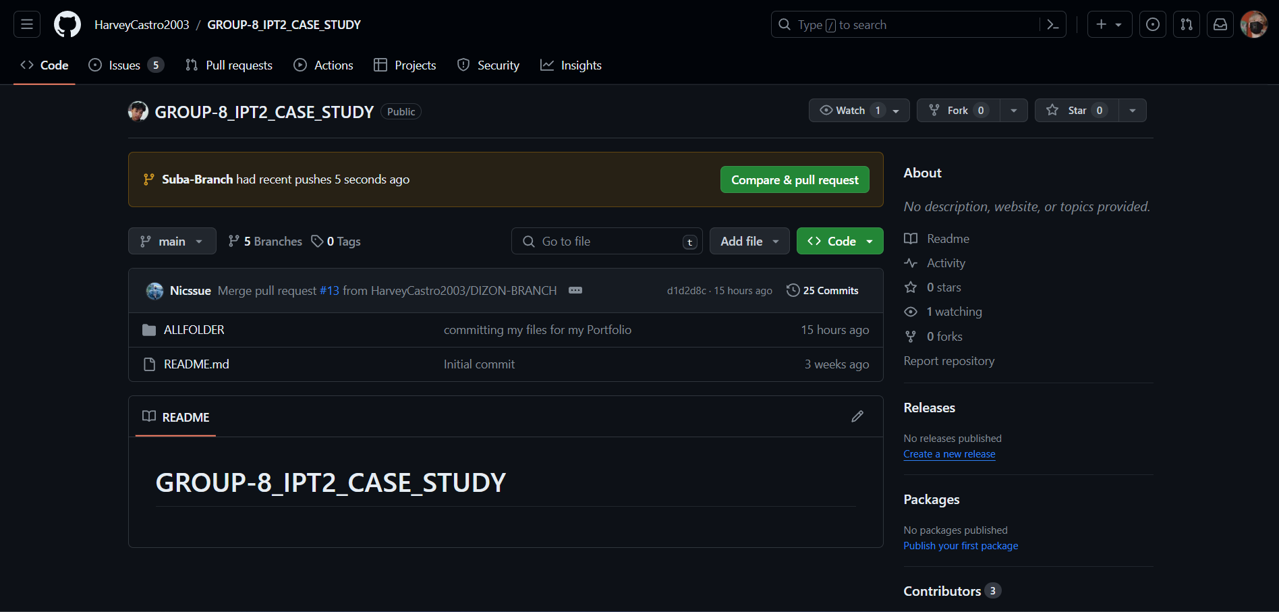

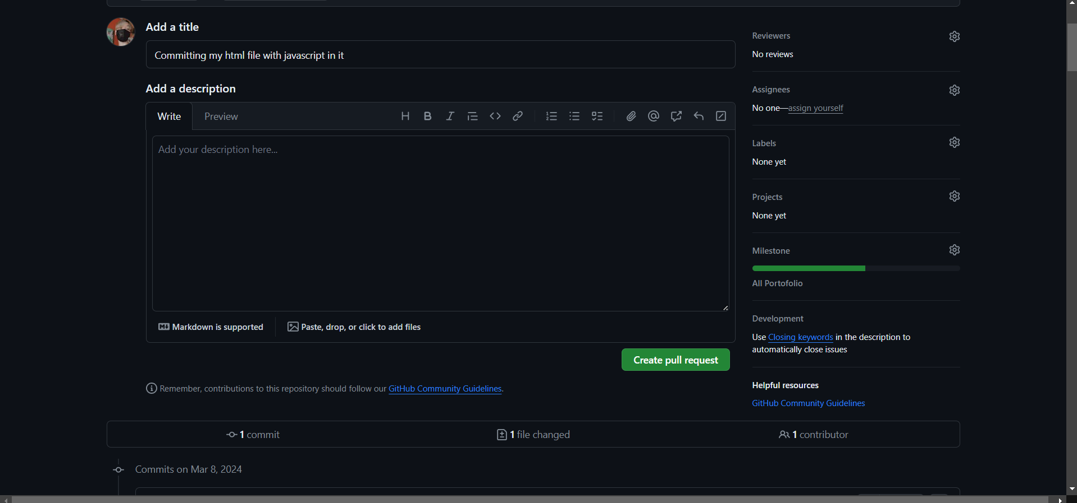

**Merged Pull in GitHub**

After the creation of Pull Request, I combined the changes from the pull request with my own branch into the main branch and verified the merge. Merging is the process in Git where separate histories.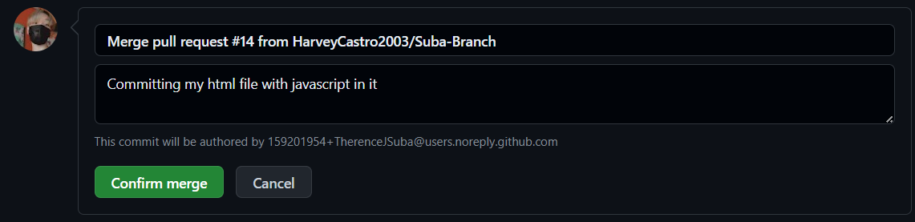

**Portfolio Output using HTML only**

This is my portfolio without using CSS and JavaScript only HTML.

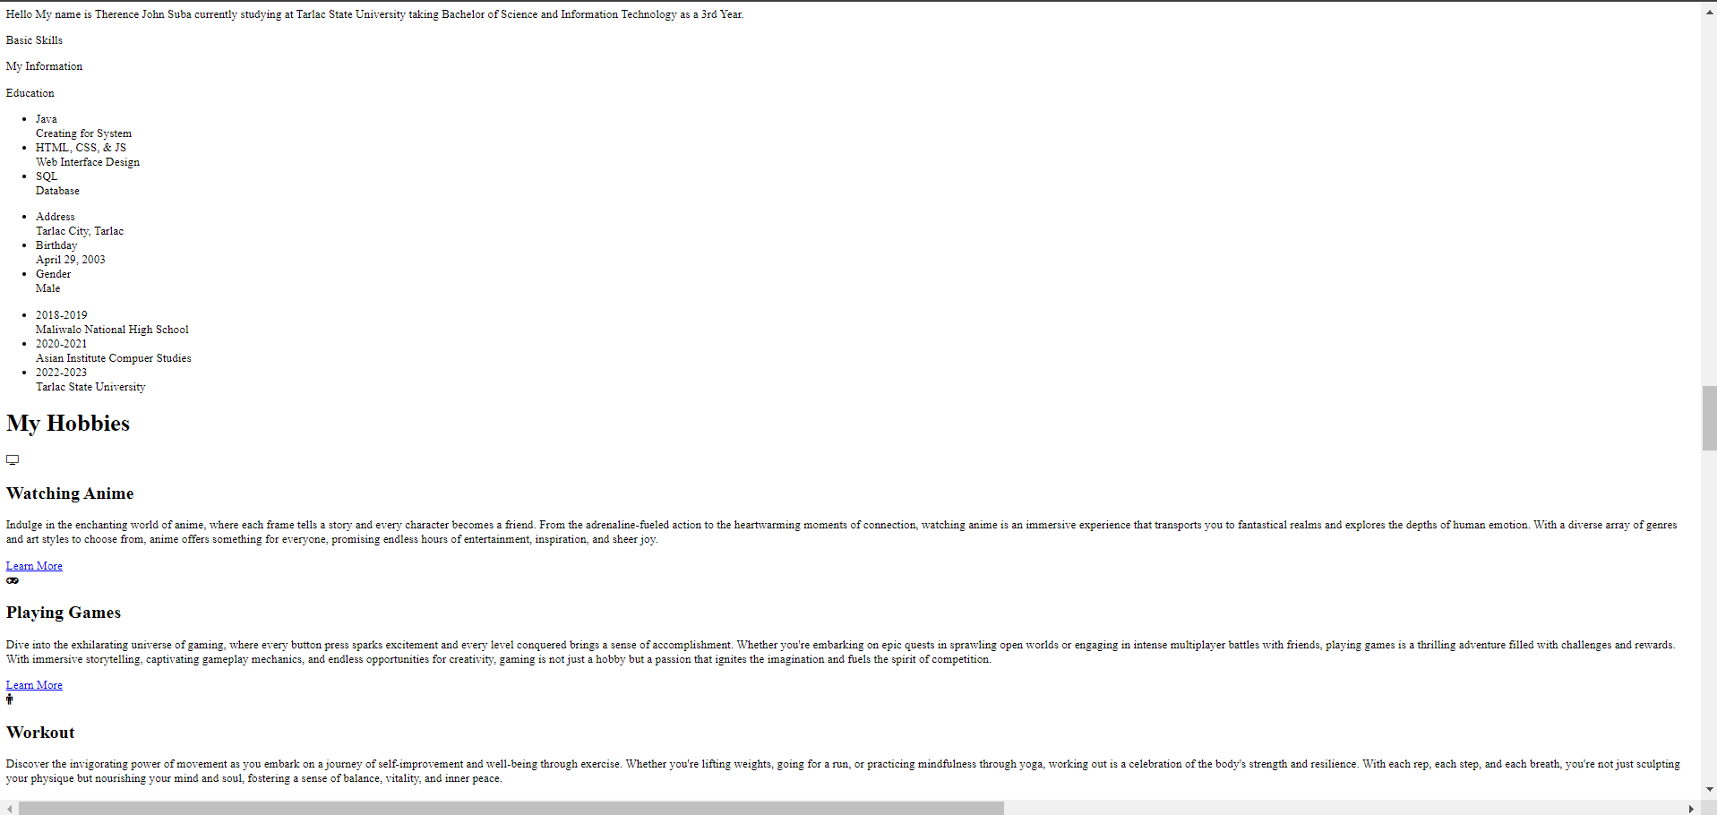

**Adding, Committing and Pushing my CSS file and Folders of Images**

First, I checked what files are in the current folder. Then, I added specific files and folders to get them ready for saving using the git add command. I added a file called "tjportfolio.css" and also added the folders named "vid" and "pic" along with everything inside them. After that, I checked to see if everything was okay. Once I was sure, I saved my changes using $ git commit.

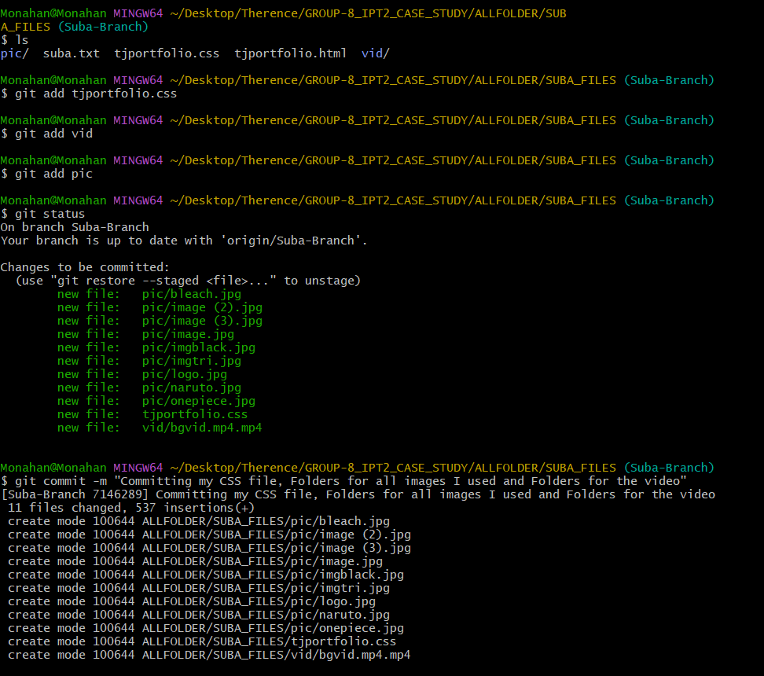

**Pull Request in GitHub**

I did Pull Request but now it is a CSS file with folders and medias inside, basically it is a method to propose changes to a repository so now my co-members can be reviewed of what are the changes

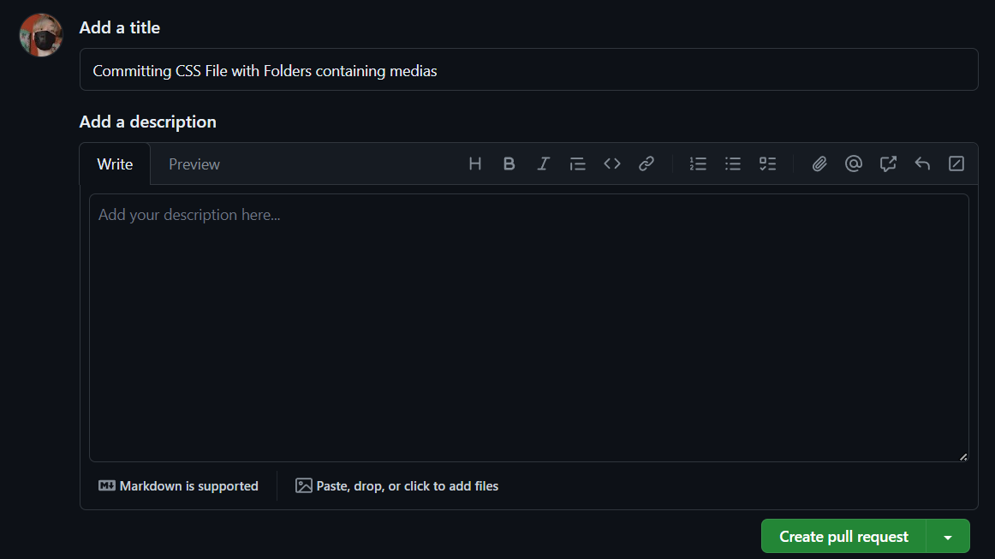

**Merged Pull in GitHub**

After initiating of Pull Request, I combined the changes from the pull request with my own branch into the main branch and verified the merge. Merging is the process in Git where separate histories.

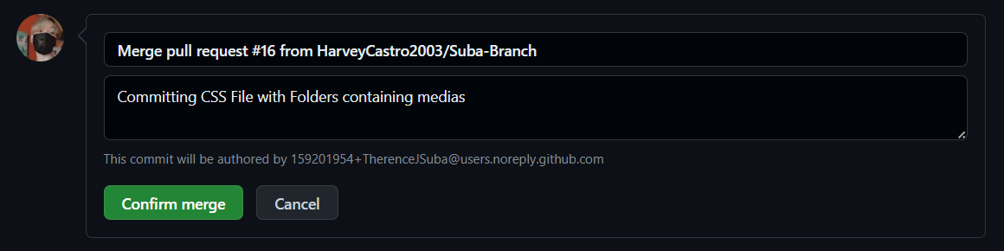

**Portfolio Output using HTML with CSS and JavaScript**

This is the output of my portfolio using HTML, CSS and JavaScript, I’ve chose black and pink for the main color since it’s my favorite among the others.

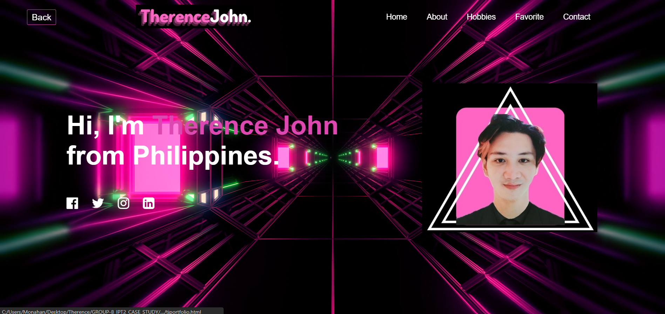

**Git Fetch**

I retrieved updates from the remote repository using git fetch

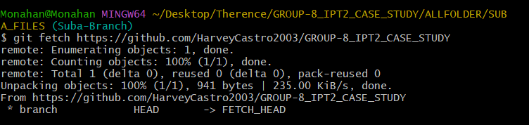

**Git Pull**

I pulled the changes from the remote repository to my local branch with git pull.

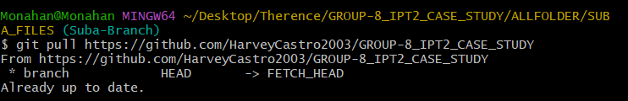

**Git Merge**

I merged the changes from the "Suba-Branch" into my current branch using git merge.

